**Problem:**

You are working as a data analyst team for the HR department in a medical company. The [data](https://drive.google.com/file/d/1AXekCqXF4cFlyOm_IEzrNvNgOKW1Qj0a/view) provided by the HR department includes 10-15 parameters per day per year (arrival/departure time, vacations, sick days, time off, etc.) on 1000+ employees of the company. Your task is to answer the following questions, which the CEO formulated:

1. Identify the most disciplined and undisciplined employees and divisions;
2. Create a visualization with the analysis of weekdays and months when the most employees were late/absent (either for vacation or sick leave);
3. Answer the following questions:
4. Which heads of departments tend to forgive employees for lack of discipline?
5. Are there any favorites for any heads of departments (perhaps some employees are always forgiven for being late, given time off, etc.)?

**Methodology:**

The purpose of this report is to gain insights and to give recommendations on the current issue of the medical company regarding employee tardiness and leaves.

The data analyst team has been tasked to help identify the employees and divisions that are the most disciplined and undisciplined. They are also tasked with finding the weekdays and months when leaves are taken and when tardiness occurred the highest.

The company has provided this [data](https://drive.google.com/file/d/1CgBfQHTHs-FTsieCn0YqNTxoPtxNcd1m/view?usp=drive_link) and the [data dictionary](https://docs.google.com/document/d/12maK1vMz_DNAmgjfUhTJrinqOC340yOr/edit?usp=drive_link&ouid=102822759885668971579&rtpof=true&sd=true) for the team to fully grasp the information within the dataset and the necessary terms to describe each table and column and its purpose.

Upon checking on the data provided, we noticed that there are certain columns in the different tables that can be merged into one single table wherein we can fully focus on finding the essential details we need for our conclusions. For good measure, we checked the data dictionary to validate which table and column we should focus on to get the answers we need.

We decided to analyze and process the provided information by running them in Power BI. In Power BI, we used the program to import, clean and make the necessary formulas to aid in our report.  
  
After we have made the necessary changes to the tables and columns, we proceeded with creating the necessary dashboards in order to thoroughly visualize what we have found and to provide the conclusions that will satisfy the data analysis goals.

**Findings:**

These are our team’s conclusions after we have extracted the answers from our discoveries:

1. The most undisciplined employee is 83902
2. The most disciplined employee is 74461
3. The most undisciplined department is the Support Centre.
4. The most disciplined department is Pharmacy.

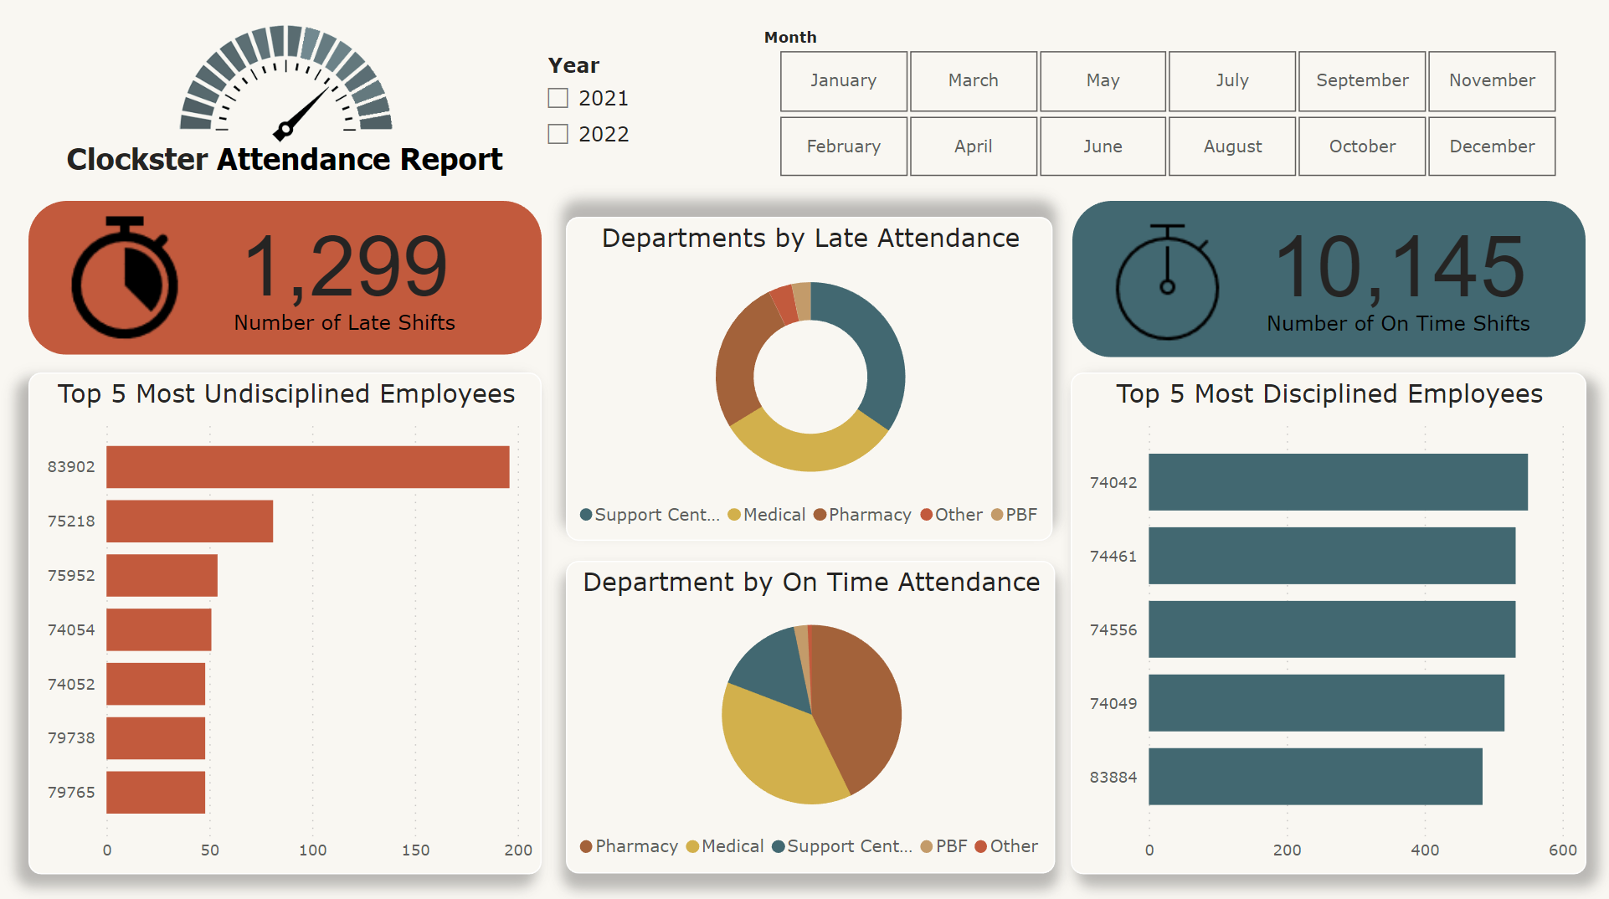

1. The day with the most number of lates is Monday.
2. The month with the most number of lates is September.
3. The day with the most number of leaves is Friday.

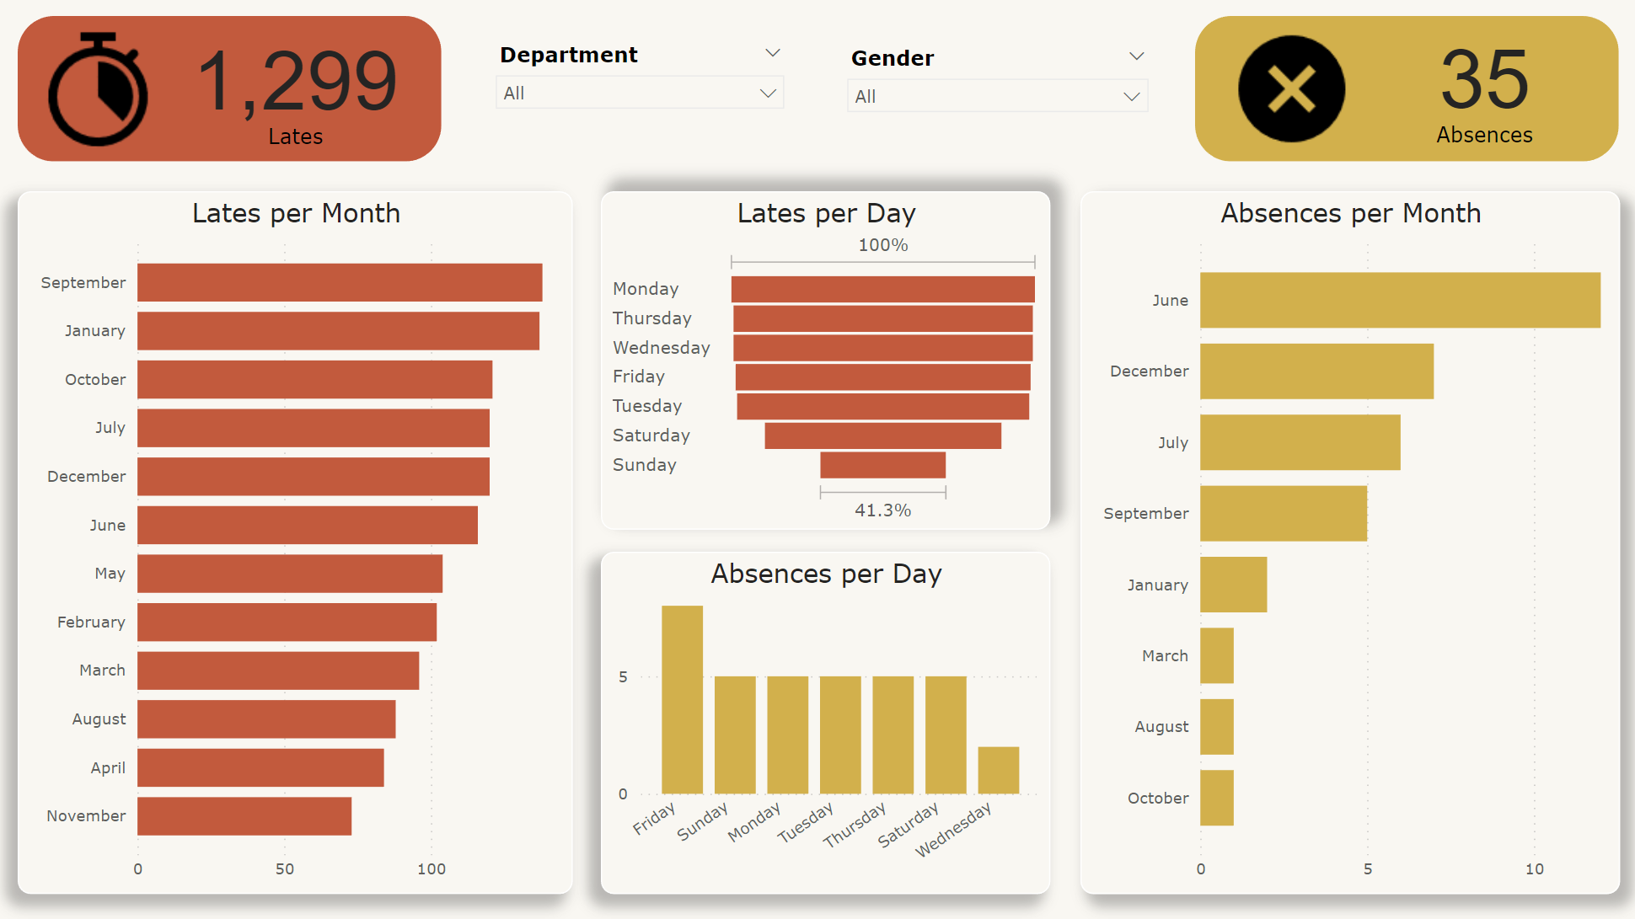

1. The department that tends to forgive their employees for lack of discipline is Medical.

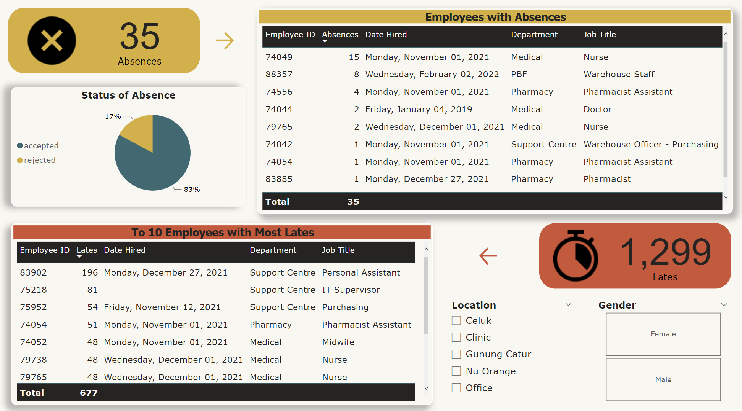

**Recommendations:**

Based on the data provided, we can safely assume that no policies have yet to be implemented for those employees with violations in regard with punctuality and attendance. We recommend addressing the problems through the following actions:

* To ensure that employees comprehend the company's expectations for attendance and punctuality, it's important to communicate these policies clearly. It's also crucial to convey the consequences of failing to comply with these policies as well as the advantages of having good attendance.
* It's also important to regularly review attendance data to detect patterns and outliers, and make adjustments to strategies accordingly. By cautiously monitoring and reviewing attendance data, we can effectively address any issues related to attendance and punctuality of the company employees. This will enable us to ensure that strategies are on track and to prevent negative impact.
* Conduct a detailed analysis of the factors contributing to the discipline levels within the organization, focusing on both individual employees and departments.
* Implement targeted interventions and initiatives to improve discipline in the undisciplined departments and among the undisciplined employees.
* From the data gathered, we can infer that there's a significant incongruence in the attendance of the employees. There are inconsistencies in the time ins and time outs, leading to inaccuracies in the data.
* Since tardiness is a prevailing issue in the company, it is worth considering implementing stricter measures when it comes to employee attendance. The company should enforce policies that will help mitigate lapses in the attendance. There should also be consequences to those undisciplined employees so that they will be much more compliant.
* Implement a much more convenient system for employees to clock in and clock out so that the data gathered will be almost free of errors. This could include using a different time tracking software, biometrics or electronic time sheets that will capture the data.
* In the case that the company will use a new software or method in gathering the data, relevant training should be first provided to the employees before implementation as it could be a factor that the latter are not familiarized with usage of the system which can lead to not being able to maintain the integrity of the data.
* Issue a reward system for disciplined employees so that the whole workforce in the company will be eager to comply with the attendance policies.
* Set a monthly limit for allowable lates and absences. Those who exceed the limit must be given a verbal warning by the Manager to ensure discipline.
* If there are no improvements from the employee following the first action, misconduct must be escalated to the Human Resources Department to issue the former a written warning i.e. Memorandum for correction of performance and to arrange seminars for the employee to attend.
* If the employee has failed to heed both warnings, the Manager and the Human Resources Department must decide if they would put the employee on a disciplinary probation until there are changes in misconduct.
* Follow up on attendance statistics and assess how well the initiatives are working. Keep tabs on attendance improvements and take immediate action to resolve any lingering problems. Depending on the information obtained from the data analysis, make any necessary modifications to policies or procedures.